Terrain Management System Control Function - CGEA 1.3 – P552 Raptor ONLY

Functional Description

The Terrain Management System (TMS) feature allows a driver to cycle through a number of preset terrain modes, each consisting of a particular steering feel, powertrain calibration, brake calibration, 4x4 system setting, variable suspension and rear differential locks.

The TMS button is actually a combination of two momentary toggle switches that allow the user to scroll either up/down or right/left (based on the HMI design) to traverse thru the available terrain modes. The SCCM provides the IPC with debounced mode button press information via CAN, which communicates whether either of the momentary toggle switches (Mode+ or Mode-) is pressed or not pressed; this information is then used by the IPC to initiate a new terrain mode request and display a corresponding pop-up screen. Each TMS request is comprised of a separate command sent to the PCM, ABS, TCCM, VDM/CCD and PSCM modules using each module’s respective terrain mode request signal.

The first press of either of the TMS Mode (+ or -) buttons shall request that the TMS pop-up be displayed, illustrating to the driver the current and available terrain modes graphically. Subsequent presses of the Mode button shall result in a new terrain mode request, after a certain time delay, as long as the TMS pop-up is active. Upon a new terrain mode request, the cluster shall verify that the PCM, ABS, TCCM, VDM/CCD and PSCM modules have entered the newly requested mode within a given amount of time by validating each module’s respective status signal.

The confirmed mode is notified to the user via a dedicated Terrain Mode RTT. Additionally, the Steering Feel RTT, 4x4 mode RTT may also change based on the confirmed Terrain mode.

Terrain Management System and Selectable Drive modes are mutually exclusive even though they provide similar functionality. The two features cannot be implemented on the same version of a cluster variant. Suppliers who may have common code supporting both should differentiate the two features via an internal configurable parameter.

Interfaces

Interface Context Diagram (I/O Block Diagram)
Figure 1: Terrain Management System Control Function Context Diagram
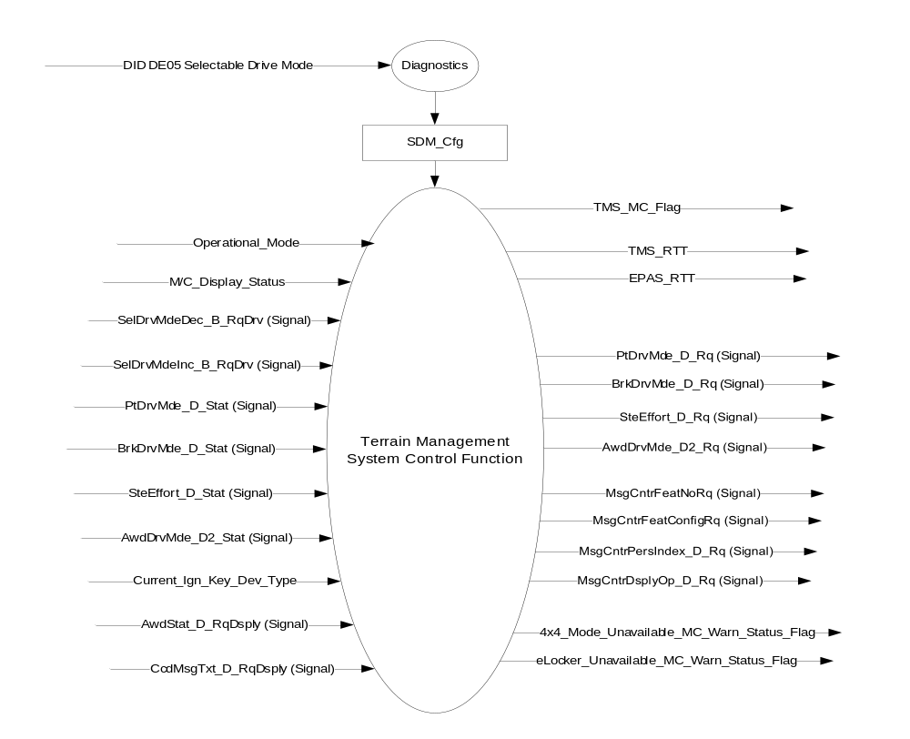

Inputs

- INTERNAL:
- Operational_Mode
- M/C_Display_Status
- Current_Ign_Key_Dev_Type (from MyKey Control Function STSS)
- SDM_Cfg - Internally stored bit based on SDM parameter of DID DE05 indicating if the SDM feature is Enabled (0x1) or Disabled (0x0)
- MUX messages on the CAN bus:

- SelDrvMdeInc_B_RqDrv Signal
Signal Name | Size  (bits) | Detail | Units | Res. | Offset | State  Encoded | Min | Max
SelDrvMdeInc_B_RqDrv | 1 |  | SED | 1 | 0 |  | 0 (0x0) | 1 (0x1)
 |  | Not pressed |  |  |  | 0x0
 |  | Pressed |  |  |  | 0x1

- SelDrvMdeDec_B_RqDrv Signal
Signal Name | Size  (bits) | Detail | Units | Res. | Offset | State  Encoded | Min | Max
SelDrvMdeDec_B_RqDrv | 1 |  | SED | 1 | 0 |  | 0 (0x0) | 1 (0x1)
 |  | Not pressed |  |  |  | 0x0
 |  | Pressed |  |  |  | 0x1

- SteEffort_D_Stat Signal
Signal Name | Size  (bits) | Detail | Units | Res. | Offset | State  Encoded | Min | Max
SteEffort_D_Stat | 3 |  | SED | 1 | 0 |  | 0 (0x0) | 7 (0x7)
 |  | Normal |  |  |  | 0x0
 |  | Sport |  |  |  | 0x1
 |  | Comfort |  |  |  | 0x2
 |  | Not Used |  |  |  | 0x3
 |  | Not Used |  |  |  | 0x4
 |  | Not Used |  |  |  | 0x5
 |  | Not Used |  |  |  | 0x6
 |  | Not Used |  |  |  | 0x7

- PtDrvMde_D_Stat Signal
Signal Name | Size  (bits) | Detail | Units | Res. | Offset | State  Encoded | Min | Max
PtDrvMde_D_Stat | 4 |  | SED | 1 | 0 |  | 0 (0x0) | 15 (0xF)
 |  | Normal |  |  |  | 0x0
 |  | Sport |  |  |  | 0x1
 |  | SnowWet |  |  |  | 0x2
 |  | TowHaulGradeAssist |  |  |  | 0x3
 |  | Sand |  |  |  | 0x4
 |  | Baja |  |  |  | 0x5
 |  | RockCrawl |  |  |  | 0x6
 |  | Not Used |  |  |  | 0x7
 |  | Not Used |  |  |  | 0x8
 |  | Not Used |  |  |  | 0x9
 |  | Not Used |  |  |  | 0xA
 |  | Not Used |  |  |  | 0xB
 |  | Not Used |  |  |  | 0xC
 |  | Not Used |  |  |  | 0xD
 |  | Not Used |  |  |  | 0xE
 |  | Faulty |  |  |  | 0xF

- BrkDrvMde_D_Stat Signal
Signal Name | Size  (bits) | Detail | Units | Res. | Offset | State  Encoded | Min | Max
BrkDrvMde_D_Stat | 3 |  | SED | 1 | 0 |  | 0 (0x0) | 7 (0x7)
 |  | Normal |  |  |  | 0x0
 |  | Sport |  |  |  | 0x1
 |  | Snow_Wet |  |  |  | 0x2
 |  | Track |  |  |  | 0x3
 |  | Drag |  |  |  | 0x4
 |  | Baja |  |  |  | 0x5
 |  | RockCrawl |  |  |  | 0x6
 |  | Faulty |  |  |  | 0x7

- AwdStat_D_RqDsply Signal
Signal Name | Size  (bits) | Detail | Units | Res | Offset | State Encoded | Min. | Max.
AwdStat_D_RqDsply | 5 |  | SED | 1 | 0 |  | 0 (0x0) | 31 (0x1F)
 |  | Normal__No  _Message |  |  |  | 0x0
 |  | Into_4Low__  Speed |  |  |  | 0x1
 |  | Into_4Low__  Brake |  |  |  | 0x2
 |  | Into_4Low__  Neutral |  |  |  | 0x3
 |  | Into_4Low__  Clutch |  |  |  | 0x4
 |  | Out_of_4Low  __Speed |  |  |  | 0x5
 |  | Out_of_4Low  __Brake |  |  |  | 0x6
 |  | Out_of_4Low  __Neutral |  |  |  | 0x7
 |  | Out_of_4Low  __Clutch |  |  |  | 0x8
 |  | Shift_In_Progress |  |  |  | 0x9
 |  | _4x4_Locked_ Temporarily |  |  |  | 0xA
 |  | _4x4_Disabled_ Temporarily |  |  |  | 0xB
 |  | _4x4_Auto_ Restored |  |  |  | 0xC
 |  | Blocked_Shift_ Assist |  |  |  | 0xD
 |  | _4x4_Off_Road_ Mode |  |  |  | 0xE
 |  | _4x4_Exiting_Off_ Road |  |  |  | 0xF
 |  | _4x4_Extreme_Off_Road_Mode |  |  |  | 0x10
 |  | _4x4_Off_Road_ Speed |  |  |  | 0x11
 |  | AWD_OFF |  |  |  | 0x12
 |  | Neutral_Tow_Enabled |  |  |  | 0x13
 |  | Neutral_Tow_Disabled |  |  |  | 0x14
 |  | Change_AWD_PTU_Oil |  |  |  | 0x15
 |  | AWD_PTU_Oil_Changed |  |  |  | 0x16
 |  | Out_of_4Low_Crawl |  |  |  | 0x17
 |  | 4x4_Mode_Unavail_TMS |  |  |  | 0x18
 |  | Lkr_Mode_Unavail_TMS |  |  |  | 0x19
 |  | Not used |  |  |  | 0x1A – 0x1F

- AwdDrvMde_D2_Stat Signal
Signal Name | Size  (bits) | Detail | Units | Res. | Offset | State  Encoded | Min | Max
AwdDrvMde_D2_Stat | 4 |  | SED | 1 | 0 |  | 0 (0x0) | 15 (0xF)
 |  | Normal |  |  |  | 0x0
 |  | Sport |  |  |  | 0x1
 |  | Weather |  |  |  | 0x2
 |  | MudAndSand |  |  |  | 0x3
 |  | Baja |  |  |  | 0x4
 |  | RockCrawl |  |  |  | 0x5
 |  | TowHaul |  |  |  | 0x6
 |  | NotAvailable |  |  |  | 0x7
 |  | NotUsed_1 |  |  |  | 0x8
 |  | NotUsed _2 |  |  |  | 0x9
 |  | NotUsed _3 |  |  |  | 0xA
 |  | NotUsed _4 |  |  |  | 0xB
 |  | NotUsed _5 |  |  |  | 0xC
 |  | NotUsed _6 |  |  |  | 0xD
 |  | NotUsed _7 |  |  |  | 0xE
 |  | Faulty |  |  |  | 0xF

- CcdMsgTxt_D_RqDsply Signal
Signal Name | Size  (bits) | Detail | Units | Res. | Offset | State  Encoded | Min | Max
CcdMsgTxt_D_RqDsply | 4 |  | SED | 1 | 0 |  | 0 (0x0) | 15 (0xF)
 |  | No_Mode_Selected |  |  |  | 0x0
 |  | Comfort |  |  |  | 0x1
 |  | Normal |  |  |  | 0x2
 |  | Sport |  |  |  | 0x3
 |  | Faulty |  |  |  | 0x4
 |  | CCD_Service_Required |  |  |  | 0x5
 |  | CCD_Temporarily_Off |  |  |  | 0x6
 |  | Mode_Change_Unavailable |  |  |  | 0x7
 |  | Not used |  |  |  | 0x8 – 0xF

    - Outputs
- TMS_RTT

- EPAS_RTT – Please refer to the “EPAS Selectable Steering Effort Control Function – S550 Specific – CGEA1.3 v3.0” or newer version of STSS for more information.

- TMS_MC_Flag
- 4x4_Mode_Unavailable_MC_Warn_Status_Flag
- eLocker_Unavailable_MC_Warn_Status_Flag
- MUX messages on the CAN bus:

- SteEffort_D_Rq Signal
Signal Name | Size  (bits) | Detail | Units | Res. | Offset | State  Encoded | Min | Max
SteEffort_D_Rq | 3 |  | SED | 1 | 0 |  | 0 (0x0) | 7 (0x7)
 |  | Normal |  |  |  | 0x0
 |  | Sport |  |  |  | 0x1
 |  | Comfort |  |  |  | 0x2
 |  | Not Used |  |  |  | 0x3
 |  | Not Used |  |  |  | 0x4
 |  | Not Used |  |  |  | 0x5
 |  | Not Used |  |  |  | 0x6
 |  | Not Used |  |  |  | 0x7

- PtDrvMde_D_Rq Signal
Signal Name | Size  (bits) | Detail | Units | Res. | Offset | State  Encoded | Min | Max
PtDrvMde_D_Rq | 4 |  | SED | 1 | 0 |  | 0 (0x0) | 15 (0xF)
 |  | Normal |  |  |  | 0x0
 |  | Sport |  |  |  | 0x1
 |  | SnowWet |  |  |  | 0x2
 |  | TowHaulGradeAssist |  |  |  | 0x3
 |  | Sand |  |  |  | 0x4
 |  | Baja |  |  |  | 0x5
 |  | RockCrawl |  |  |  | 0x6
 |  | Not Used |  |  |  | 0x7
 |  | Not Used |  |  |  | 0x8
 |  | Not Used |  |  |  | 0x9
 |  | Not Used |  |  |  | 0xA
 |  | Not Used |  |  |  | 0xB
 |  | Not Used |  |  |  | 0xC
 |  | Not Used |  |  |  | 0xD
 |  | Not Used |  |  |  | 0xE
 |  | Faulty |  |  |  | 0xF

- BrkDrvMde_D_Rq Signal
Signal Name | Size  (bits) | Detail | Units | Res. | Offset | State  Encoded | Min | Max
BrkDrvMde_D_Rq | 4 |  | SED | 1 | 0 |  | 0 (0x0) | 15 (0xF)
 |  | Normal |  |  |  | 0x0
 |  | Sport |  |  |  | 0x1
 |  | SnowWet |  |  |  | 0x2
 |  | Track |  |  |  | 0x3
 |  | DragOrMudAndSand |  |  |  | 0x4
 |  | Baja |  |  |  | 0x5
 |  | RockCrawl |  |  |  | 0x6
 |  | Faulty |  |  |  | 0x7

- AwdDrvMde_D2_Rq Signal
Signal Name | Size  (bits) | Detail | Units | Res. | Offset | State  Encoded | Min | Max
AwdDrvMde_D2_Rq | 4 |  | SED | 1 | 0 |  | 0 (0x0) | 15 (0xF)
 |  | Normal |  |  |  | 0x0
 |  | Sport |  |  |  | 0x1
 |  | Weather |  |  |  | 0x2
 |  | MudAndSand |  |  |  | 0x3
 |  | Baja |  |  |  | 0x4
 |  | RockCrawl |  |  |  | 0x5
 |  | TowHaul |  |  |  | 0x6
 |  | NotAvailable |  |  |  | 0x7
 |  | NotUsed_1 |  |  |  | 0x8
 |  | NotUsed _2 |  |  |  | 0x9
 |  | NotUsed _3 |  |  |  | 0xA
 |  | NotUsed _4 |  |  |  | 0xB
 |  | NotUsed _5 |  |  |  | 0xC
 |  | NotUsed _6 |  |  |  | 0xD
 |  | NotUsed _7 |  |  |  | 0xE
 |  | Faulty |  |  |  | 0xF

- MsgCntrDsplyOp_D_Rq Signal
Signal Name | Size (bits) | Detail | Units | Res. | Offset | State Encoded | Min | Max
MsgCntrDsplyOp_D_Rq | 3 |  | SED | 1 | 0 |  | 0  (0x0) | 7  (0x7)
 |  | NULL |  |  |  | 0x0
 |  | QUERY |  |  |  | 0x1
 |  | SET |  |  |  | 0x2
 |  | UPLOAD |  |  |  | 0x3
 |  | RESTORE |  |  |  | 0x4
 |  | COPY |  |  |  | 0x5
 |  | Unused |  |  |  | 0x6
 |  | Unused |  |  |  | 0x7
.
- MsgCntrFeatConfigRq Signal
Signal Name | Size (bits) | Detail | Units | Res. | Offset | State  Encoded | Min | Max
MsgCntrFeatConfigRq | 16 |  | Undefined | 1 | 0 |  | 0  (0x0) | 65535  (0xFFFF)

- MsgCntrFeatNoRq Signal
Signal Name | Size (bits) | Detail | Units | Res. | Offset | State  Encoded | Min | Max
MsgCntrFeatNoRq | 16 |  | Number | 1 | 0 |  | 0  (0x0) | 65535  (0xFFFF)

- MsgCntrPersIndex_D_Rq Signal
Signal Name | Size (bits) | Detail | Units | Res. | Offset | State Encoded | Min | Max
MsgCntrPersIndex_D_Rq | 3 |  | SED | 1 | 0 |  | 0  (0x0) | 7  (0x7)
 |  | PERS_1 |  |  |  | 0x0
 |  | PERS_2 |  |  |  | 0x1
 |  | PERS_3 |  |  |  | 0x2
 |  | PERS_4 |  |  |  | 0x3
 |  | Vehicle |  |  |  | 0x4
 |  | Unused |  |  |  | 0x5
 |  | Unused |  |  |  | 0x6
 |  | Unused |  |  |  | 0x7

Function/Performance

Operational Modes

Mode | Differentiating Vehicle Conditions
Sleep Mode | Terrain Management System Control Function Disabled
Limited Mode | Terrain Management System Control Function Disabled
Normal Mode | Terrain Management System Control Function Enabled / Disabled
Crank Mode | Terrain Management System Control Function Enabled / Disabled

Voltage Levels

Refer to the Cluster Features table located in the Operational Modes and Voltage Range Strategies Section in this SPSS.

Human-Machine Interface

Visual

Please refer to the product specific graphics wallpaper for accurate graphics required for this feature.

.

Indicator Graphics / Display Format
For actual symbol pixel definition, see product specific HMI requirements.

Indicator Color Coordinates

Refer to program specific HMI requirements for styling direction.

Indicator Characteristics

Pixel display in Message Center Display – TMS_RTT. (Example graphics of TMS RTT)

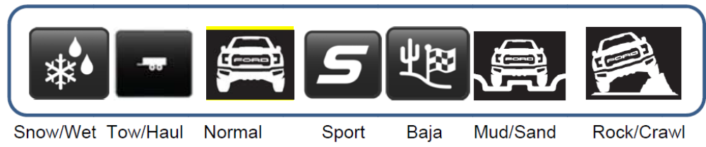

Audio

None

Switch Control Logic

The SCCM module transmits an event periodic CAN signal to inform the IPC if either of the buttons (Mode+ or Mode-) is pressed or not pressed. The SCCM handles all switch debouncing and fault conditions related to the momentary toggle switches without relaying this information to the cluster. A button press is defined as a transition from Not Pressed to Pressed. There is no press and hold for the buttons – a press and hold shall constitute a single button press.

System Accuracy

Within a 100msec of receiving a message that results in a change of state the cluster will update the display to the proper status.

Operation: Performance and Functional

Subsystem Algorithm Flowcharts / State Diagrams

Figure 2: Selectable Drive Mode Control Feature Diagnostic Configuration Flowchart

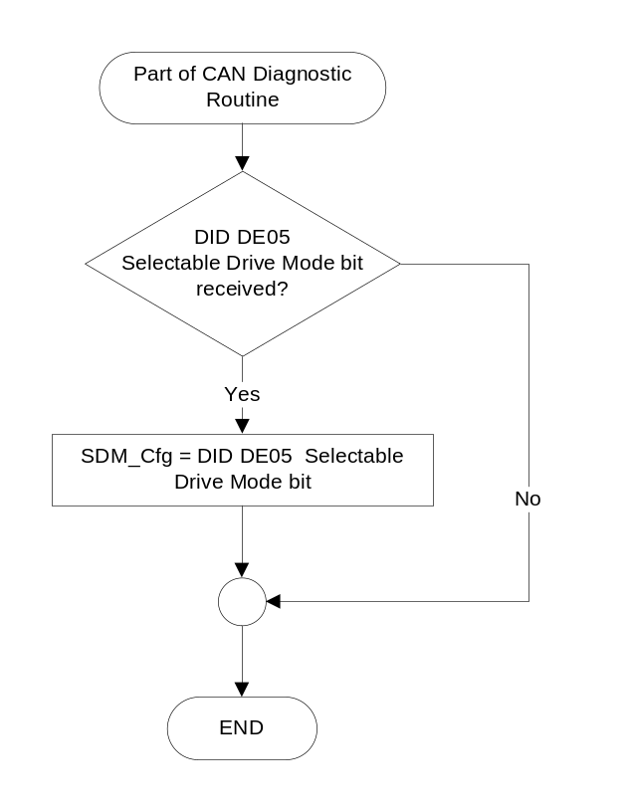

Figure 3: Terrain Management System Control Function Flowchart
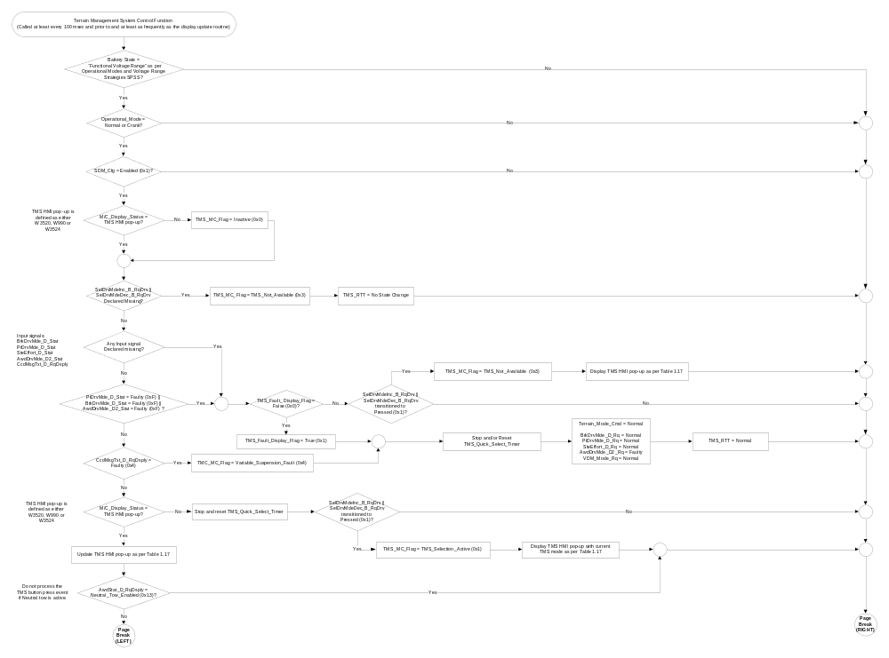
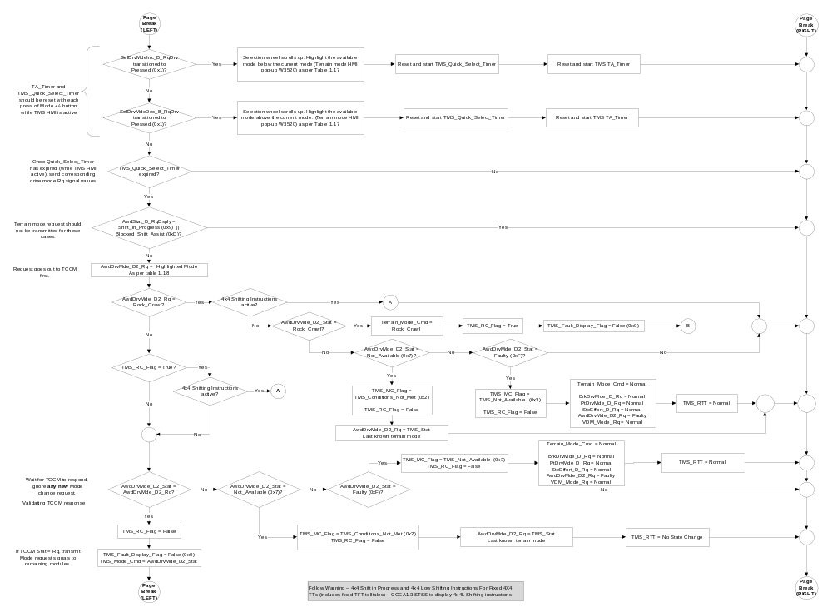

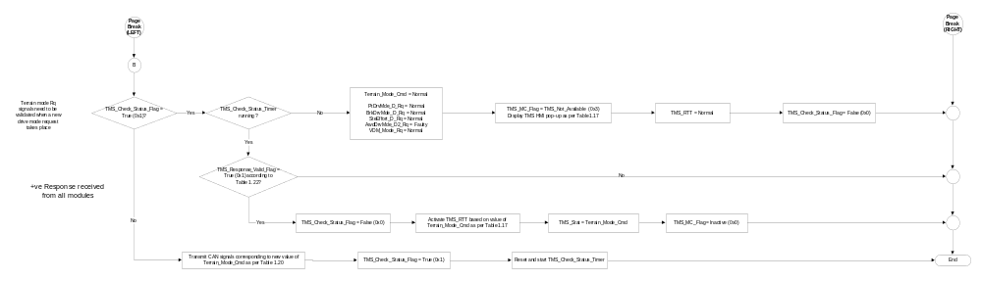

- Terrain Mode Availability Based SDM_Cfg and MyKey Settings
SDM_Cfg | Current_Ign_Key_Dev_Type | TMS_Vehicle_Status | Valid States for Terrain_Mode_Cmd
Enabled (0x1) | <> Key_In_Ign_My_Key (0x2) | 0x1 | Sippery (0x2)  Tow/Haul (0x6)  Normal (0x0)  Sport (0x1)  Baja (0x4)  Deep Snow/Sand (0x3)  Rock Crawl (0x5)
Enabled (0x1) | Key_In_Ign_My_Key (0x2) | 0x2 | Slippery (0x2)  Tow/Haul (0x6)  Normal (0x0)

- Sample Graphics and MC WARNING MESSAGE ID #

Based on TMS_MC_Flag
SDM_Cfg | TMS_MC_Flag | MC WARNING  MESSAGE ID # | TMS Pop-up Sample Graphics  *See Note Below
Enabled (0x1) | Inactive (0x0) | None | 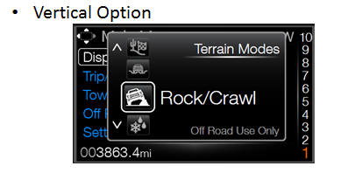
Enabled (0x1) | TMS_Selection_Active  (0x1) | W3520 | Terrain Mode Selection Window/Carousel  (example graphics to be provided upon availibility)
Enabled (0x1) | TMS_Conditions_Not_Met (0x2) | W3524 | Selected Terrain  Mode  Preconditions  Not Met
Enabled (0x1) | TMS_Not_Available  (0x3) | W990 | Terrain Management System  Not Available
Enabled (0x1) | Variable_Suspension_Fault (0x4) | W1027 | Driver Selectable Suspension Manlfunction Service Required
All Other Cases |  | X | No graphic shown

Note: W3520 should illustrate the available terrain modes based on Table 1.16, where the highlighted/focused
mode is the current value of Terrain_Mode_Cmd

- Highlighted Mode to TCCM Request Signal

Quick Select Timer | Highlighted TMS Mode | AwdDrvMde_D2_Rq Signal
Expired | Normal (0x0) | Normal  (0x0)
Expired | Sport (0x1) | Sport  (0x1)
Expired | Slippery (0x2) | Weather  (0x2)
Expired | Deep Snow/Sand (0x3) | Mud&Sand  (0x3)
Expired | Baja (0x4) | Baja  (0x4)
Expired | Rock Crawl (0x5) | Rock Crawl  (0x5)
Expired | Tow/Haul (0x6) | Tow/Haul (0x6)
All Other Cases | X | Do Not Transmit

Note: The order of the modes is per table 1.16 or HMI direction.

- SDM_Response_Valid_Flag State Matrix

AwdDrvMde_D2_Stat Signal | Terrain_Mode_Cmd
Normal  (0x0) | Normal  (0x0)
Sport  (0x1) | Sport  (0x1)
Weather  (0x2) | Slippery  (0x2)
Mud&Sand  (0x3) | Deep Snow/Sand  (0x3)
Baja  (0x4) | Baja  (0x4)
Rock Crawl  (0x5) | Rock Crawl  (0x5)
TowHaul (0x6) | Tow/Haul (0x6)
Not_Available (0x7) | Not_Available (0x7)
Faulty (0xF) | Faulty (0x8)
- TMS Mode Cmd to Terrain Mode Signals Mapping

State Matrix for PCM, ABS, EPAS
Terrain_Mode_Cmd | PtDrvMde_D_Rq Signal | BrkDrvMde_D_Rq Signal | SteEffort_D_Rq Signal | VDM_Mode_Rq
Normal (0x0) | Normal (0x0) | Normal (0x0) | Normal (0x0) | Normal (0x0)
Sport (0x1) | Sport (0x1) | Sport (0x1) | Sport (0x1) | Sport (0x1)
Slippery (0x2) | SnowWet (0x2) | Snow_Wet (0x2) | Normal (0x0) | Normal (0x0)
Deep Snow/Sand (0x3) | Mud & Sand (0x4) | Mud & Sand (0x4) | Comfort (0x2) | Off Road (0x2)
Baja (0x4) | Baja (0x5) | Baja (0x5) | Normal (0x0) | Off Road (0x2)
Rock Crawl (0x5) | Rock Crawl (0x6) | Rock Crawl (0x6) | Comfort (0x2) | Off Road (0x2)
Tow/Haul (0x6) | TowHaulGradeAssist (0x3) | Normal (0x0) | Normal (0x0) | Normal (0x0)
Not Available (0x7) | Do Not Transmit | Do Not Transmit | Do Not Transmit | Do Not Transmit
Faulty (0x8) | Normal (0x0) | Normal (0x0) | Normal (0x0) | Normal (0x0)

Note: for “Not Available”, the cluster shall transmit the previously confirmed state to the TCCM via the AwdDrvMde_D2_Rq signal as per figure 1.3

Note: for, “Faulty”, the cluster shall transmit “Faulty” to the TCCM via the AwdDrvMde_D2_Rq signal as per figure 1.3

Note: The order of the modes is per table 1.16 or HMI direction.

The VDM_Mode_Rq variable used in the table above is a combination of 4 personalization signals based on the table below.

- VDM_Mode_Rq to IPC Transmit signals
VDM_Mode_Rq | MsgCntrFeatNoRq  Signal | MsgCntrPersIndex_D_Rq Signal | MsgCntrDsplyOp_D_Rq  Signal | MsgCntrPersIndex_D_Rq  Signal
Off Road (0x2) | 0x0B00 | Comfort (0x1) | Set (0x2) | Vehicle (0x4)
Normal (0x0) | 0x0B00 | Normal (0x2) | Set (0x2) | Vehicle (0x4)
Sport (0x1) | 0x0B00 | Sport (0x3) | Set (0x2) | Vehicle (0x4)

- SDM_Response_Valid_Flag State Matrix
Terrain_Mode_Cmd | PtDrvMde_D_Stat  Signal | BrkDrvMde_D_Stat  Signal | SteEffort_D_Stat  Signal | AwdDrvMde_D2_Stat  Signal | CcdMsgTxt_D_RqDsply Signal | SDM_Response_Valid_Flag
Normal (0x0) | != Faulty (0xF) | Normal (0x0) | Don’t Care | Normal (0x0) | Normal (0x2) | True (0x1)
Sport (0x1) | != Faulty (0xF) | Sport (0x1) | Don’t Care | Sport (0x1) | Sport (0x3) | True (0x1)
Slippery (0x2) | != Faulty (0xF) | Snow_Wet (0x2) | Don’t Care | Weather (0x2) | Normal (0x2) | True (0x1)
Deep Snow/Sand (0x3) | != Faulty (0xF) | Mud & Sand (0x4) | Don’t Care | Mud & Sand (0x3) | Comfort (0x1) | True (0x1)
Baja (0x4) | != Faulty (0xF) | Baja (0x5) | Don’t Care | Baja (0x4) | Comfort (0x1) | True (0x1)
Rock Crawl (0x5) | != Faulty (0xF) | Rock Crawl (0x6) | Don’t Care | Rock Crawl (0x5) | Comfort (0x1) | True (0x1)
Tow/Haul (0x6) | != Faulty (0xF) | Normal (0x0) | Don’t Care | TowHaul (0x6) | Normal (0x2) | True (0x1)
Faulty (0x8) | != Faulty (0xF) | Normal (0x0) | Normal (0x0) | Normal (0x0) | Normal (0x2) | True (0x1)
All other cases |  |  |  |  |  | False (0x0)

Note: The order of the modes is per table 1.16 or HMI direction.
The cluster shall not monitor the SteEffort_D_Stat signal to confirm the Terrain mode. The SteEffort_D_Rq request signal, however, will still get transmitted by the cluster when a mode is requested.

- TMS_RTT, EPAS_RTT Based on SDM_Drive_Mode_Cmd
Terrain_Mode_Cmd | TMS_RTT | EPAS_RTT | 4x4 Status RTT | Diff Lock Status
Normal (0x0) |   Normal (0x0) | SteEffort_D_Stat | See Note 2 | State of RearDiffLckLamp_D_Rq Signal
Sport (0x1) |   Sport (0x1) | SteEffort_D_Stat | See Note 2 | State of RearDiffLckLamp_D_Rq Signal
Slippery (0x2) |   Slippery (0x2) | SteEffort_D_Stat | See Note 2 | State of RearDiffLckLamp_D_Rq Signal
Deep Snow/Sand (0x3) |   Deep Snow/Sand (0x3) | SteEffort_D_Stat | See Note 2 | State of RearDiffLckLamp_D_Rq Signal
Baja (0x4) |   Baja (0x4) | SteEffort_D_Stat | See Note 2 | State of RearDiffLckLamp_D_Rq Signal
Rock Crawl (0x5) |   Rock Crawl (0x5) | SteEffort_D_Stat | See Note 2 | State of RearDiffLckLamp_D_Rq Signal
Tow/Haul (0x6) |   Tow/Haul (0x6) | SteEffort_D_Stat | See Note 2 | State of RearDiffLckLamp_D_Rq Signal
Not Available (0x7) | No State Change | No State Change | See Note 2 | State of RearDiffLckLamp_D_Rq Signal
Faulty (0x8) | Normal | SteEffort_D_Stat | See Note 2 | State of RearDiffLckLamp_D_Rq Signal
All other cases | Normal (0x0) | Inactive | Inactive | Inactive
Note: The states of the EPAS_RTT, 4x4 Mode, Variable Suspension mode and Diff Lock are the default states associated with each of the Terrain modes. These states may change based on independent (of Terrain mode) selection of the modes.

Note 2: The state of the 4x4 mode RTT is dependent on the Awd2wdLamp_D_RqDsply, AwdAutoLamp_D_RqDsply, AwdHiLamp_D_RqDsply or the AwdLoLamp_D_RqDsply signal based on the default 4x4 state associated with the TMS mode.

There are certain terrain modes during which the driver will not be able to engage the Electronic Locking Differential or independently change the 4x4 mode to his/her liking. (example: 4x4 Low will not be available during Sport mode). The following warnings will get displayed to inform the driver whenever a desired 4x4 mode or eLocker is unavailable based on the selected Terrain mode.

- State Matrix for 4x4 Fault Warnings for TMS
Operational_Mode | SDM_Cfg | AwdStat_D_RqDsply Signal | 4x4_Mode_Unavailable_  MC_Warn_Status_Flag | eLocker_Unavailable_  MC_Warn_Status_Flag
Normal or Crank | Enabled (0x1) | 4x4_Mode_Unavail_TMS (0x18) | Active | Inactive
Normal or Crank | Enabled (0x1) | Lkr_Mode_Unavail_TMS  (0x19) | Inactive | Active
All Other Cases |  |  | Inactive | Inactive

- MC Status Flag to MC Warning Message ID
4x4_Mode_Unavailable_  MC_Warn_Status_Flag | eLocker_Unavailable_  MC_Warn_Status_Flag | MC Warning ID
Active | X | W3521
X | Active | W3522
X = Don’t care

Operation Description (supports algorithm flowcharts / state diagrams)

- There is no interaction between the 5-way steering wheel switches and the TMS feature. TMS is controlled directly via an external, two-way momentary toggle switch (Mode+ and Mode-), which is located in the SCCM. The SCCM is responsible for sending debounced pressed/not pressed information to the cluster via the SDMIncButtnPress or the SDMDecButtnPress signals.

- The first press of either the Mode+ or the Mode- buttons shall bring up the TMS HMI pop-up. Subsequent presses of either of these two buttons shall advance the HMI to the next state/mode if the TMS HMI pop-up is active. Terrain_Mode_Cmd and the corresponding CAN Rq signals shall not change until after the Quick_Select_Timer has elapsed according to the logic in Figure 3.

- The Mode+ button shall advance the HMI to the next mode by scrolling to the right of the array. If the highlighted mode happens to be the first one in the array, the button shall advance the HMI to the last available mode in the array (wrap around).

- The Mode- button shall advance the HMI to the next mode by scrolling to the left of the array. If the highlighted mode happens to be the last one in the array, the button shall advance the HMI to the first available mode in the array (reverse wrap around).

- Each press of the Mode (+ or -) button shall reset and restart the TA_timer for the TMS HMI pop-up if the TMS HMI is already active.

- If the TMS HMI is interrupted by any other pop-up or warning before the Quick_Select_Timer has elapsed, the TMS mode selection process should be aborted.

- Once the Quick_Select_Timer has elapsed, if another pop-up or warning gets activated, the TMS pop-up shall be deactivated as soon as the TMS mode display has been updated. (The TMS mode update can be concluded as complete once the “TMS_Check_Status_Flag” has a value of “False” (0x0) and corresponding RTT (if applicable) has been activated.).The TMS pop-up shall not wait for the minimum display timer to expire.

- Based on the HMI layout, W3520 (Terrain mode selection carousel/window) may or may not share the same area on the display as the other warning messages. However, regardless of the layout, W3520 shall be treated as a temporary alert (TA*) warning type.

- Therefore, if TMS_MC_Flag <> TMS_Selection_Active (0x1), or if the requested mode has been confirmed, then W3520 should be dismissed.

- “Sport”, “Baja”, “Deep Snow/Sand” and “Rock Crawl” modes shall not be available for selection when a vehicle is driven using a MyKey. The cluster shall either gray out or not display the unavailable modes. (Product specific HMI strategy).

- Upon key-on, TMS_Mode_Cmd shall default to Normal (0x0), PtDrvMde_D_Rq shall default to Normal (0x0), BrkDrvMde_D_Rq shall default to Normal (0x0), AwdDrvMde_D2_Rq shall default to Normal (0x0), VDM_Mode_Rq shall default to Normal and SteEffort_D_Rq shall default to EPAS_Keyon_Effort as per “EPAS Selectable Steering Effort Function - S550 Specific - CGEA 1.3_v2.0+”.

- The IPC is responsible for requesting TMS modes, but it is the acting modules’ responsibility to make the appropriate decisions to determine if the request can be fulfilled and respond positively or negatively via its status signal.

- The IPC shall transmit the user selected mode request via the AwdDrvMde_D2_Rq to the TCCM first. Based on the status response from the TCCM (via the AwdDrvMde_D2_Stat), the IPC shall then determine and transmit request signals to the other modules (PCM, ABS and EPAS).

- If the “AwdStat_D_RqDsply = 0x9, 0xD or 0x13, the IPC shall display the corresponding warning messages and wait for the TCCM to respond on the AwdDrvMde_D2_Stat signal.

- When TCCM sends Not Available on the status signal, this triggers the IPC to resend the previously achieved Terrain Mode. During that time IPC will be sending the previously attained mode and TCCM could still transmit Not available at the same time (could be for 1 or 3 CAN periodic cycles). Under that condition IPC shall wait until TCCM status updates with a matching terrain mode or Faulted state.

- Once the user selected mode request is transmitted to the TCCM, the IPC shall ignore new mode requests if the “AwdStat_D_RqDsply” is equal to 0x9 (Shift in Progress), 0xD (Block Shift Assist) or 0x13 (Neutral Tow Enabled”.

- If an AWD mode is changed independent of the TMS, that AWD shall be retained thru key cycles unless it is changed via a terrain mode request or if the user changes it again manually.

- The AWD shifting instructions shall not stop the Terrain management mode selection process flow. If an AWD mode requires shifting instructions as part of changing the terrain mode, the shifting instruction messages shall replace the Terrain Mode pop-up. If the user clears the shifting instructions, the cluster shall revert to the screen that was active prior to the shifting instructions (most likely the TMS selection window). If the shifting instructions are not cleared by the user, the cluster shall wait until the warning times out or the warning becomes inactive before returning to the screen that was active prior to the shifting instructions (most likely the TMS selection window).

- Depending on the preconditions and other factors, the entry or exit out of 4x4 Low could take up to 30 seconds. During that time, the IPC shall wait for the TCCM to respond on the AwdDrvMde_D2_Stat signal.

- The individual RTTs (EPAS, AWD mode, Selectable Dampers and e-locker) shall be made controllable through the individual functional STSS requirements if changed via the individual button presses.

- The Terrain Management System Control Function uses the same configuration parameter as the Selectable Drive Mode function. This is because the two features are mutually exclusive. However, if a supplier finds it difficult to differentiate TMS with SDM, they may use an internal supplier configuration parameter at their own discretion. Terrain Management and Selectable Drive mode will never be offered on the same vehicle.

Function Safety Classification (EMC)

Class B

Memory Storage
Parameter Name | Description | Value at  Battery Connect | Value at  Module Wake-up | Value at Transition  to Run/Start
Operational_Mode | 4 state indicator for cluster operational mode. | Limited | Limited, Normal or Crank
Current_Ign_Key_Dev_Type | Used to indicate the type of key currently in use in the vehicle. This parameter is identical in encoding to the IgnKeyType_D_Actl signal. | See STSS: “MyKey Control Function” | See STSS: “MyKey Control Function” | See STSS: “MyKey Control Function”
M/C_Display_Status | State indicator to identify which text is currently being displayed on Message Center display. See * | See * below | See * below | See * below
SelDrvMdeInc_B_RqDrv | Input CAN signal that provides the debounced state of the SDM Mode + button (Pressed / Not pressed). | Not pressed (0x0) | Not pressed (0x0) | Not pressed (0x0)
SelDrvMdeDec_B_RqDrv | Input CAN signal that provides the debounced state of the SDM Mode - button (Pressed / Not pressed). | Not pressed (0x0) | Not pressed (0x0) | Not pressed (0x0)
PtDrvMde_D_Stat | Input CAN signal that provides the current powertrain mode status. | Normal (0x0) | Normal (0x0) | Normal (0x0)
BrkDrvMde_D_Stat | Input CAN signal that provides the current ABS mode status. | Normal (0x0) | Normal (0x0) | Normal (0x0)
SteEffort_D_Stat | Input CAN signal that provides the current EPAS steering feel status. | Normal (0x0) | Normal (0x0) | Normal (0x0)
AwdDrvMde_D2_Stat | Input CAN signal that provides the current TCCM/AWD mode status. | Normal (0x0) | Normal (0x0) | Normal (0x0)
AwdStat_D_RqDsply | Output CAN signal sent from TCCM. | Normal_No_  Message (0x0) | Normal_No_  Message (0x0) | Normal_No_  Message (0x0)
CcdTxtMsg_D_RqDsply | Output CAN signal transmitted by the VDM. | Normal (0x2) | Normal (0x2) | Normal (0x2)
PtDrvMde_D_Rq | Output CAN signal to request a certain powertrain drive mode. | Normal (0x0) | Normal (0x0) | Normal (0x0)
BrkDrvMde_D_Rq | Output CAN signal to request a certain ABS-ESC mode. | Normal (0x0) | Normal (0x0) | Normal (0x0)
SteEffort_D_Rq | Output CAN signal to request a certain EPAS steering feel. | Normal (0x0) | See STSS: “EPAS Selectable Steering  Effort Function -  S550 Specific - CGEA 1.3 _v2.0+” | See STSS: “EPAS Selectable Steering  Effort Function -  S550 Specific - CGEA 1.3 _v2.0+”
AwdDrvMde_D2_Rq | Output CAN signal to request a certain AWD mode setting | Normal (0x0) | Normal (0x0) | Normal (0x0)
MsgCntrDsplyOp_D_Rq Signal | Output Signal to indicate Request Type. | NULL (0x0) | Do Not Init | MsgCntrDsplyOp_D_Rq Signal
MsgCntrFeatNoRq Signal | Output Signal to indicate Feature Number. | (0x0000) | Do Not Init | MsgCntrFeatNoRq Signal
MsgCntrFeatConfigRq Signal | Output Signal to Specify the desired feature Value. | (0x0000) | Do Not Init | MsgCntrFeatConfigRq Signal
MsgCntrPersIndex_D_Rq Signal | Output Signal to indicate which personality profile is being accessed. | Vehicle (0x4) | Do Not Init | MsgCntrPersIndex_D_Rq Signal
TMS_Check_Status_Flag | Internal parameter used to flag if the TMS handshaking (status checking) logic should take place. | False (0x0) | False (0x0) | False (0x0)
SDM_Cfg | Internal flag used to indicate if SDM feature is present in the vehicle. | Use Stored Value | Use Stored Value | Use Stored Value
TMS_Mode_Cmd | Internal parameter that represents the current requested SDM mode. This parameter is identical in encoding to the Selectable_Drive_Mode_Stat DID. | Normal (0x0) | Normal (0x0) | Normal (0x0)
TMS_Fault_Display_Flag | Internal parameter used to flag if TMS fault has occurred and has already been displayed. | False (0x0) | False (0x0) | False (0x0)
TMS_MC_Flag | Internal flag used to control the state of the SDM selection pop-up. This variable can dismiss the SDM selection pop-up prior to the expiration of the TA_Timer. | Inactive (0x0) | Inactive (0x0) | Inactive (0x0)
TMS_RTT | TMS output displayed as an RTT. | Normal (0x0) | Normal (0x0) | Normal (0x0)
4x4_Mode_Unavailable_  MC_Warn_Status_Flag | Output state variable used by the M/C warning arbitrator | Inactive | Inactive | Inactive
eLocker_Unavailable_  MC_Warn_Status_Flag | Output state variable used by the M/C warning arbitrator | Inactive | Inactive | Inactive
TMS_Response_Valid_Flag | Internal parameter used to check if drive mode status signals (from PCM, ABS, and PSCM) are valid after a new drive mode request. | False (0x0) | False (0x0) | False (0x0)
TMS_Stat | Internal variable that holds the value of user selected Terrain mode. | Normal (0x0) | Normal (0x0) | Normal (0x0)
TMS_Vehicle_Status | Internal parameter that indicates the vehicle status based on Table 1.11. | 0x0 | 0x0 | 0x0
* Refer to Message Center X Display_Y Button Interface Section, where X and Y are appropriate values in this document.

Timer Name | Duration | Description | Min | Max | Resolution
TMS_Check_Status_Timer | 300ms | Used to limit the amount of time that EPAS, VDM, PCM, and ABS modules have to respond positively to a change in SDM mode. | 0ms | 2000ms | 50ms
TMS_Quick_Select_Timer | 700ms | Used to suppress the transmission of new SDM mode requests in between SDM button presses. | 0ms | 3000ms | 50ms
Note: Timers shall be programmable within the shown range, to at least the max value listed. Higher max values and finer resolutions are acceptable.

Reconfigurable Telltale

Yes. See Section 1.3.3.2 Indicator Graphics / Display Format, and Table 1.23.

Prove Out

Not applicable.

Message Center Msg

W990, W3520, W3521, W3522, W3524, W1027 as per the Global message list.

Error Handling

Missing Message Strategy

The signals will be declared missing as per the Diagnostics section of this STSS.
DTCs states and history will be determined as per the Diagnostics section of this STSS.
If SDM_Cfg = Disabled, the cluster shall never log a missing message DTC due to this feature.

Diagnostics

Self Test

None.

Engineering Test Mode

Reference section “Dealer / Engineering Test Mode (ETM)”

Part II Performance

Supported Diagnostic DIDs (Service $22)
Number | DID / Common ID Name | PID Type | Comments / Information
$FDXX | Selectable_Terrain_Mode_Stat | State Encoded | This DID will report the most recently requested drive mode.  0x0 = Normal  0x1 = Sport  0x2 = Slippery  0x3 = Deep Snow/Sand  0x4 = Baja  0x5 = Rock Crawl  0x6 = Tow/Haul  0x7 - 0xF = Reserved
Note: Selectable_Terrain_Mode_Stat is a supplier DID, which follows the same encoding as TMS_Mode_Cmd. This DID should be read-only.

DID $DEXX:
Block  Num | Block Description | Byte(s) | Bits | State: Description | "0" | "1" | Default | Comments
PACKETED BLOCKS
$05 | Option Content (B&A) | * | * | Selectable Drive Mode | Disabled | Enabled | Disabled | Disabled means the feature is not offered on the vehicle.
 | *Byte and bit location to be identified in Part II Specification for this cluster

Supported Diagnostic Trouble Codes (DTCs)

DTCs shall be logged as per the diagnostics section of this SPSS.*

DTC | Description
C10000 | Lost Communication With ECM/PCM "A"
C12100 | Lost Communication With Anti-Lock Brake System (ABS) Control Module
C13100 | Lost Communication With Power Steering Control Module (PSCM)
C21200 | Lost Communication With Steering Column Control Module (SCCM)
C10200 | Lost Communication with Transfer Case Control Module (TCCM)
C40100 | Invalid Data Received from ECM/PCM (PtDrvMde_D_Stat = Faulty (0xF)
C41500 | Invalid Data Received From Anti-Lock Brake System (ABS) Control Module (BrkDrvMde_D_Stat = Faulty (0x7)
C40300 | Invalid Data Received from Transfer Case Control Module (AwdDrvMde_D2_Stat = 0xF)
* If the missing signal has a related update bit, _UB, signal, then the “Invalid Data” DTC is to be logged. Otherwise, the “Lost Communication” DTC is logged.

Reference Specifications

IS-0001 WARNINGS/INDICATORS/DISPLAYS PROVEOUT
IS-0052 OPERATING VOLTAGES - FUNCTIONAL/PERFORMANCE
IS-0069 FUNCTIONAL IMPORTANCE CLASS
IS-0324 WINDSHIELD & OTHER REFLECTIONS
IS-0327 WARNING INDICATOR EVALUATION
IS-0379 NORTH AMERICAN WARNINGS AND INDICATORS STRATEGY

IL-0019 GENERAL ILLUMINATION DIMMING
IL-0021 CRAFTSMANSHIP - DISPLAYS
IL-0022 GENERAL ILLUMINTATION COLOR
IL-0023 CLARITY/LEGIBILITY/READABILITY
IL-0025 INTERIOR ILLUMINATION INTENSITY
IL-0045 COLOR
IL-0048 ILLUMINATION ACCEPTABILITY

03-0661 PLACEMENT: CONTROL AND DISPLAY LOCATIONS
03-0662 PLACEMENT: LOGICAL GROUPING FUNCTION AND USAGE
03-0664 PLACEMENT: DOWN VISION TO COMPONENTS WITH HIGH VISUAL DEMAND
03-0665 PLACEMENT: EXPECTED LOCATIONS OF CONTROLS AND DISPLAYS VDS
03-0670 INTERIOR VISIBILITY
03-0671 INTERIOR VISIBILITY: REFLECTIONS FROM COMPONENTS & SURFACES
03-0672 INTERIOR VISIBILITY: REFLECTIONS IN DISPLAYS
03-0673 INTERIOR VISIBILITY: VISUAL OBSCURATIONS
03-0674 INTERIOR VISIBILITY: ILLUMINATION CONTROLS / DISPLAYS
03-0677 INTERIOR VISIBILITY: SUNLIGHT WASHOUT
03-0681 IDENTIFICATION: CHARACTER AND SYMBOL SIZE
03-0682 IDENTIFICATION: LEGIBILITY
03-0685 IDENTIFICATION: SYMBOLS, ABBREV FOR CONTROL
03-0721 LOGIC OF OPERATION: OPERATIONAL STEREOTYPES
03-0722 LOGIC OF OPERATION: INTERPRETATION
03-0723 LOGIC OF OPERATION: USE OF SYSTEMS WITH VISUAL DISPLAYS

Revision History
STSS Module Revision History
Revision Level | Name | Change Description | Date
1.0 | V. Patel | Initial release of Terrain Management System feature cluster specification for P552 Phantom variant. STSS design leveraged from “Selectable Drive Mode Control Function – S550 SVT Specific – CGEA1.3” STSS.  Feature owners: Wroblewski, Thomas; Leese, Michael (P552 Phantom Electrical Program team); Campagnolo, Enzo (Vehicle Integration) | 3/23/2015
1.1 | V. Patel | The purpose of this update is to add two warnings that were previously missed. These warnings notify the user if a desired 4x4 mode or eLocker is unavailable in the currently selected Terrain mode.  Section 1.2.1: Updated context diagram to define the output warning flags.  Section 1.2.2: Added the two new output warning flag variables.  Section 1.3.5.1: Added two tables (1.18 and 1.19) to process the warnings and associate with a message ID.  Section 1.3.5.4: Added the output warning variables in the parameter Initialization table. | 10/8/2015
1.2 | V. Patel | This updates addresses a recent issue where cluster displayed a fault warning when Tow Haul was selected. It was per the system spec, however, change is required per PCM strategy. When user requests “Normal” mode, the cluster shall accept “Normal” or “TowHaulGradeAssist” as valid status from the PCM status signal.  Section 1.3.5.1, figure 7: Updated decision diamond to check if the cluster is already in “Normal” mode or if “Normal” mode is in request.  Section 1.3.5.1, table 1.16: Updated 1st cell of the table to accept “Normal” or “TowHaulGradeAssist” as valid response from the PCM when “Normal” is requested. | 1/14/2016
1.3 | V. Patel | This update clarifies a requirement that was not stated correctly, which caused a s/w issue.  Section 1.3.5.2: Made it clear that the AWD shifting instructions could be part of the mode selection and thus shall not stop the terrain mode selection process flow. (Requirement highlighted in yellow) | 2/5/2016
1.4 | V. Patel | Direction from Ford Performance team is to change the steering feel in the Baja mode from “Sport” to “Normal”.  Section 1.3.5.1:  Table 1.15: Changed the state of SteEffort_D_Rq for Baja from Sport to Normal.  Table 1.16: Changed the state of SteEffort_D_Stat for Baja from Sport to Normal.  Table 1.17: Changed the Steering feel RTT for Baja from Sport to Normal. | 2/12/2016
1.5 | V. Patel | No change to feature functionality. Spec updated to provide clarifications to supplier concerns/questions.  Section 1.3.5.1,  Figure 3: Removed “AwdDrvMde_D_Stat” missing from the 6th decision diamond since it is checked further down in the flowchart as well.  Figure 7: Removed the decision diamond that checks for “STM_Response_Valid_Flag” since it is not required.  Also set the TMS_Mode_Cmd to Normal whenever there is a fault in the system, this way the selection window will also display normal whenever the Mode button is pressed. | 4/21/2016
1.6 | V. Patel | This update fixes an issue where the AWD part of the Terrain mode was not returning to Normal upon ignition cycle.  Section 1.3.5.2: Added AwdDrvMde_D_Rq to the 9th bullet item be set to Normal upon every key cycle. (Updated text shown in Red)  Section 1.3.5.4: Added a column to the Memory Storage table. This will ensure that all module requests (except for Steering) will return to Normal upon a new ignition cycle regardless of how short the Key-off time was. | 5/3/2016
1.7 | V. Patel | An issue was recently found where Terrain mode request was being transmitted while Neutral tow was active. This update fixes the issue, where the TMS request will not be transmitted to the TCCM if Neutral Tow is active along with a couple of other cases.  Section 1.3.5.1, figure 3: Moved the decision diamond (page 9) that checks for Neutral Tow, so that it is checked before any request is transmitted by the cluster. | 5/20/2016
1.8 | V. Patel | Fixed an issue in the previous release, the decision diamond that checks for Neutral tow needed to be moved up one layer more. The decision is made before the signal to the TCCM is sent out. | 5/23/2016
1.9 | V. Patel | An issue was recently discovered where the PCM changed its Terrain Mode status to Normal when Hill Descent was activated while in a non-Normal Terrain mode. This mismatch caused the cluster to display a Fault as per the system requirements. Similarly, when the user changed the 4x4 mode to Low while in Baja, the PCM changed its status to Normal, again causing the cluster to display a Fault message as per the requirements.  The cluster has been asked to make a change to its strategy to fix this issue. As per direction from TMS feature owner (Tom Wroblewski) and PCM (Seth Goslawski), the cluster will only monitor and take action if the PCM transmits a Fault. Else, the cluster will not take action if PCM status does not match the TMS request.  Offline DI CC approval: 6/28/2016  Section 1.3.5.1, table 1.16: Changed the first column (in red) of the PtDrvMde_D_Stat to monitor only Faulty status. Everything else will return a TMS true condition from a PCM perspective. | 6/29/2016
1.10 | V. Patel | This update addresses 2 issues found during vehicle testing.  - IPC was transmitting a stored value of the terrain mode request and transmitting it as soon as Neutral tow was disabled. This should not happen. The user should not be allowed to change the terrain mode for as long as Neutral Tow is enabled and active.  Section 1.3.5.1, figure 3: Moved the Neutral Tow active condition check up to before the TMS buttons are processed. This way, the IPC will not take any action if the user tries to change the terrain mode while Neutral Tow is active. The “Shift in Progress” and “Block Shift Assist” conditions stay as is in the flowchart.  - If a new Steering mode was changed within 300 msec of requesting a Terrain mode, the system would generate a fault. This is because the EPAS module was responding to the TMS request when another independent request was issued to change the Steering mode.  Section 1.3.5.1, table 1.16: Raptor team wants IPC to ignore the status transmitted by the EPAS module. Changed the contents of the SteEffort_D_Stat signal column to “Don’t Care”.  Table 1.17 Changed the state of the EPAS RTT to follow the states of the SteEffort_D_Stat signal. | 8/22/2016
2.0 | V. Patel | Major updates to support Tow Haul and few other updates/changes to support MY19 Raptor program.  For MY19 Raptor, treat this as a new spec.  Current production (MY17, MY18 Raptor shall not update to version 2.0. | 2/10/2017
2.1 | V. Patel | This update changes the VDM_Mode_Rq state for Deep Snow/Sand mode in table 1.20 from “Normal” to “Off Road” as per direction from feature owner Tom Wroblewski (P552 Raptor team). The change in section 1.3.5.1, table 1.20 is shown in red.  DI CC offline approval: 10/2/2017  Also fixed a few typos in the signal names. The AwdDrvMde_D2_Stat signal in some instances was still being spelled as the old “AwdDrvMde_D_Stat” signal.  Also replaced the word “Phantom” with “Raptor” in the title and name of the of the document. | 10/2/2017
2.2 | V. Patel | In changing the request for the variable suspension mode request for Deep Sand/Snow mode from Normal to Comfor, forgot to update the matrix that checks for the response signals from affected modules to confirm the requested terrain mode.  Section 1.3.5.1, table 1.22: Updated the CcdMsgTxt_D_RqDsply signal to “Comfort” for Deep Snow/Sand confirmation.  Table 1.23: Updated the variable suspension mode RTT to Off Road for Deep Snow/Sand mode. | 10/17/2017
2.3 | V. Patel | The suspension mode has been moved to the Raptor status screen, which means the pertaining RTT does not need to be displayed.  Feature owner: P552 Raptor team  DI CC approval: 3/27/2018 (offline)  Section 1.2.1, figure 1: Deleted Variable_Suspension_RTT from context diagram.  Section 1.2.3: Deleted Variable_Suspension_RTT as an output.  Table 1.23: Deleted the column for Variable_Suspension_RTT since it is not to be displayed as a RTT anymore.  Section 1.3.5.4: Deleted Variable_Suspension_RTT from the table. | 3/27/2018

